Positive Handling & Physical Intervention Policy



Policy Document | Positive Handling and Physical Intervention Policy
Publication Date | September 2025
Review Date | September 2026
Executive Headteacher | Jo Anderson

This policy is written so it complies with the Independent School Standards and is taken from the National Curriculum and Ofsted framework.

Contents
- Introduction………………………………………………………………… 3
- Aims……………………………………………………..…………............. 3
- Legislation and Statutory Guidance……………………………………… 3
- Positive Behaviour Management …….…………..………….…............. 4
- Restrictive Physical Interventions.………………………………………. 5
- Guidance for Using Physical Interventions…………..…………………. 6
- Reporting and Recording ……………………………….…………......... 7
- After the Incident ……………………………………..…………………… 7
- Staff Training…………………………….……………………..………… 8
- Responding to Complaints.………………………………………………… 8
- Monitoring…………………………………………………………………... 8
- Links with Other Policies…………………………………………………… 8
- Appendix 1: Restrictive Physical Intervention Form…………………… 9

- Introduction
“The term ‘positive handling’ describes a broad spectrum of risk reduction strategies. Positive handling is a holistic approach involving policy, guidance, management of the environment and deployment of staff. It also involves personal behaviour, diversion, diffusion and de-escalation. Restraint is only a small part of the framework.”
- Aims
The purpose of this policy is to ensure:
- The safe response to and management of extremely challenging or disruptive behaviour
- Staff understand company expectations and deliver consistent responses to pupils who exhibit challenging behaviour
- Pupils experience a high degree of predictability, aiding sensible decision-making at times of distress
- Minimum risk of harm to pupils, staff and visitors to the school
- Ensure adequate training for new staff as part of the Induction Training, as well as on-going ‘refresher’ training for established staff
- Ensure all staff understand the importance of developing strong, influential relationships with pupils
- Ensure there are clear expectations made of pupils and staff
- Ensure all staff feel empowered to challenge unwanted or dangerous behaviour
- Ensure processes are properly followed with correct documentation completed to evidence safe management of the pupils

- Legislation and Statutory Guidance
The use of all forms of physical intervention and physical contact is governed by criminal and civil law. The unwarranted or inappropriate use of force may constitute an assault. In addition, it may infringe the human rights of a child or young person.
Section 93 of the Education and Inspections Act 2006 enables school staff to use reasonable force to prevent a pupil from:
- committing a criminal offence
- causing personal injury or damage to property
- prejudicing the maintenance of good order and discipline at the school or among the pupils, whether during a teaching session or otherwise.
As included in the DFE 2010 guidance on ‘The use of force to control or restrain pupils’, seclusion should only be considered in exceptional circumstances, and it is an offence to lock a person in a room without a court order. Therefore, at no time should the door be locked, as to do so is unlawful and can amount to the false imprisonment of a pupil.
This policy uses DfE guidance ‘Reducing the Need for Restraint and Restrictive Intervention’ June 2019 to ensure The Oaks has a positive and proactive approach to behaviour.
Use of Reasonable Force: Advice for Executive Headteachers, Headteachers, staff and governing bodies (July 2013)
- The term ‘reasonable force’ covers the broad range of actions used by most teachers at some point in their career that involve a degree of physical contact with pupils.
- Force is usually used either to control or restrain. This can range from guiding a pupil to safety by the arm through to more extreme circumstances where a pupil needs to be restrained to prevent violence or injury.
- ‘Reasonable in the circumstances’ means using no more force than is needed.
- Control means either passive physical contact, such as standing between pupils or blocking a pupil's path, or active physical contact, such as leading a pupil by the arm out of a classroom.
- Restraint means to hold back physically or to bring a pupil under control.
- School staff should always try to avoid acting in a way that might cause injury, but in extreme cases, it may not always be possible to avoid injuring the pupil.
Schools can use reasonable force to:
- remove disruptive children from the classroom where they have refused to follow an instruction to do so;
- prevent a pupil from behaving in a way that disrupts a school event or a school visit;
- prevent a pupil from leaving the classroom where allowing the pupil to leave would risk their safety or lead to behaviour that disrupts the behaviour of others;
- prevent a pupil from attacking a member of staff or another pupil
- restrain a pupil at risk of harming themselves through physical outbursts.
- stop a pupil behaving in a way that is seriously disrupting a lesson, causing distress to the pupils and/or a breakdown of order
Schools cannot use force as a punishment – it is always unlawful to use force as a punishment.

- Positive Behaviour Management
All staff should adopt a positive approach to improving behaviour in order to reward effort and application and to build self-esteem.
Staff should refer to The Oaks Behaviour Policy when developing and implementing Individual Behaviour Plans. All pupils will have an individual Behaviour Plan and Risk Assessment and staff will ensure they:
- meet the pupil’s needs
- encourage the pupil to make positive choices and develop self-control
- support the pupil in difficult situations
- safely manage crises if and when they occur
The fundamental principle underlying our holistic approach to positive handling is to look at all the events surrounding a crisis, not just the crisis itself. Every effort will be made to identify triggers and ascertain the functions of behaviour. Where possible, a variety of techniques will be used to de-escalate situations. Care of all involved will be at the forefront of all actions and support, and time for de-briefing will be made available. All actions will be recorded, monitored and assessed to ensure best practice and constant improvement. Our school uses Team Teach positive handling techniques when a child needs guidance, escorting, holding, or restraining to safeguard their welfare and the welfare of others are upheld. All staff receive initial training in this when they first start work at our school, and ongoing training is provided throughout the year/once a year.
All who work within the school will be encouraged and trained to assess continually:

Use of space
It is essential that all space within the school building is used as effectively and safely as possible. Where triggers or difficulties are identified for any pupils, efforts will be made to adapt environments or make changes in order to promote a positive learning environment and reduce stress. Staff need to take into account the space around the pupil and, if possible, move to a suitable space.
Distractions
Distractions can be an effective tool to prevent behaviour from escalating. Working together as a team creates greater opportunities for creative thinking and progression of skills.
Calm stances, expressions and posture
It is essential that all those within the school are aware of the messages their body language is communicating. The adoption of non-threatening stances and movements can often de-escalate situations. Facial expression and tone of voice are also taken into consideration. This is particularly important in an environment where more conventional communication methods can be challenging for individuals involved.
Careful use of words
Communication must be clear. Language used must be simple, concise and suited to the individual. Where certain words or phrases are identified as triggers, this information is communicated through individual behaviour plans and risk assessments. The roles of all involved are clearly defined to minimise unnecessary discussion and demands or requests from more than one source. Scripts may be used between staff members to quickly and concisely communicate vital information.
Physical reassurance and prompts
During training, all staff members are made aware of the law regarding physical contact and the respect for personal space and dignity. Many pupils respond to nurturing support, where appropriate physical reassurance and prompts may be used. Often, by their use, more critical situations and increased physical intervention can be avoided.
Effective Guides and Escorts
These may be used to safely move individuals from one area to another (only after a verbal request and for a very short distance).
Restrictive Physical Interventions/holds
As previously stated, the welfare of the child will always be of paramount consideration and, where holds are necessary, the minimum force for the minimum amount of time will be used. Some techniques may involve minimal discomfort (July 2002 Guidance for Restrictive Physical Intervention).

- Risk Assessment for Use of Restrictive Physical Interventions
The Oaks acknowledges that some children behave in ways that make it necessary to consider the use of restrictive physical intervention as part of a behaviour management plan.
All identified behaviours requiring physical intervention should be formally risk-assessed.
The resulting risk management strategy must be compatible with a positive behaviour management approach. Planned use of physical intervention must be in keeping with the pupil’s own individual behaviour plan. As stated, IBPs will be completed after a pupil assessment is completed and a greater understanding of the needs of the pupil is gained.
In the event of any incident occurring during assessments, staff will use their training and knowledge to manage behaviour in the safest way possible.
Any physical intervention must be recorded in accordance with The Oaks' recording policy.
All staff should be aware of the distinction between physical contact or touch, used appropriately in everyday situations to support, encourage, guide or comfort a pupil, and the use of force to restrict movement or to disengage from pupils whose behaviour presents a clear risk of injury.
Techniques and methods for controlling and restraining pupils using restrictive physical interventions must be assessed to ensure they are safe, suitable and appropriate for use with the named pupil, taking into account their physical, emotional or medical needs.
The Oaks uses Team Teach. The level and duration of any intervention used should be the minimum necessary to achieve the desired result, such as to restore safety. At no point should physical intervention be used to enforce compliance or be used as a sanction by staff. Corporal punishment is strictly prohibited in The Oaks.

- Guidance for Using Physical Intervention
6.1 Power of members of staff to restrain pupils
Restraint could be undertaken following failure of all attempts at de-escalation in the following circumstances.
- A member of the staff may use, in relation to any pupil, such force as is reasonable in the circumstances for the purpose of preventing the pupil from doing (or continuing to do) any of the following, namely:
- committing any offence,
- causing personal injury to, or damage to the property of, any person (including the pupil him/herself), or
- engaging in any behaviour prejudicial to the maintenance of good order and discipline or among any of its pupils, whether that behaviour occurs during a teaching session or otherwise.
- Subsection (1) applies where a member of staff is –
- on the premises of the school/education site, or
- elsewhere at a time when, as a member of its staff, they have lawful control or charge of the pupil concerned; but it does not authorise anything to be done in relation to a pupil which constitutes the giving of corporal punishment within the meaning of section 548
- Subsection (1) shall not be taken to prevent any person from relying on any defence available to them otherwise than by virtue of this section.
- In this section –
- "member of the staff", in relation to a school, means any teacher who works at the school and any other person who, with the authority of the Executive Headteacher, has lawful control or charge of pupils at the school
- "offence" includes anything that would be an offence but for the operation of any presumption that a person under a particular age is incapable of committing an offence.

6.2 Guidance for using positive intervention to prevent a young person from absenting themselves from The Oaks
All actions taken by staff should always be in line with the local authority agreed Care Plan, Risk Assessments, and Individual Behaviour Plan for the pupil, taking into account their age, vulnerability, any disability and known history.
There are times when it is legally permissible to positively intervene to prevent a pupil from absenting themselves from the classroom. These are:
- When there is a likelihood of significant injury or harm to themselves or others
- Serious damage to property at some time in the predictable future
- To prevent severe disruption to others’ learning

- Reporting and Recording
Within 24 hours, following a physical intervention, a Restrictive Physical Intervention (RPI) form will be completed by the members of staff (see Appendix 1). The RPI form will be recorded as soon as possible after the incident. Once completed, a Senior Leader quality assures and comments on the use of physical intervention. The form is then printed and signed by staff within 48 hours. Where injuries are sustained, entries will be made in the appropriate logs and relevant people informed (parents/carers, Executive Headteacher, etc.).
The report will include:
- the name(s) of the pupil(s) and staff members involved;
- when and where the incident took place;
- the name(s) of any other staff or pupils who witnessed the incident;
- antecedent;
- the reason that intervention was necessary;
- the strategies which were employed prior to using physical intervention;
- what physical intervention was used;
- the pupil’s response, and the outcome of the incident;
- any other action taken in the management of the incident.
- details of any injury suffered by the pupil/another pupil/member of staff, and
- any damage to property

- After the Incident
The Executive Headteacher or Head of school will ensure that each incident is reviewed and investigated further as required. It is the role of the school leadership team to support staff who work with pupils with challenging behaviour. If further action is required in relation to a member of staff or a pupil, this will be pursued through the appropriate procedures:
- Review of Individual Behaviour Plan
- Child Protection Procedure (this may involve investigations by Police and/or Social Services)
- Staff or Pupil Disciplinary Procedures
- School Behaviour Policy
- Exclusions Procedure in the case of serious violence or assault against a member of staff
- Risk assessment if necessary
- The member of staff will be kept informed of any action taken.
- In the case of any action concerning a member of staff, he/she will be advised to seek advice from his/her professional association/union.
Physical Intervention data, such as pupil, de-escalation strategies used and reason for physical intervention, will be collected and reviewed by the senior leadership team to spot patterns or training needs.
- Staff Training
To ensure that such intervention is consistently applied, all staff will receive training and regular refresher courses in the Principles and Practice of Team Teach, a nationally recognised system.
Team Teach is a specialist research and training organisation founded over 15 years ago. The overall aim of the organisation is to provide high-quality training in the specialist field of managing aggressive and potentially violent behaviour. Team teach training provides a non-aversive approach to challenging behaviour. ‘Our mission is to support individuals and organisations in moving beyond behaviour management; using strategies that lower risk, build relationships, minimise physical intervention, and create positive environments. – Team Teach’
All physical interventions are in keeping with the guidelines issued under the Children Act 2004 and DfEE Circular 10/98.
Heavy emphasis is placed on de-escalation within the Team Teach system.. All staff are also to be fully conversant with individual risk assessments and the Individual Behaviour Plans for pupils. Following an incident, a debrief is conducted with the pupil, along with careful ongoing work to address issues, ensuring greater stability and helping prevent the repeated use of positive physical intervention.
Staff will not participate in physical intervention or restraint without being trained to do so, through training from a qualified Team Teach Instructor, unless to avert serious injury or danger in the most exceptional circumstances (Duty of Care). Staff have a duty of care (United Nations Convention on the Rights of the Child 1991). Where a behaviour requiring intervention has occurred once, procedures, planning and assessment will take place to ensure that any further instances are dealt with efficiently and safely.
- Responding to Complaints
The use of physical intervention may at times lead to allegations of inappropriate or excessive use. In the event of a complaint being made in relation to the use of force by staff, the matter should be dealt with by the Executive Headteacher, who will refer to The Oaks complaints and/or Safeguarding Policy.
- Monitoring
This policy will be reviewed annually by the Executive Headteacher. At every review, the policy will be shared with the Proprietor.
All teaching staff are expected to read and follow this policy. Senior Leaders, Teachers and support staff are responsible for ensuring that the policy is followed.

- Links with other policies
This Positive Handling and Physical Intervention Policy is linked to:
- Safeguarding
- Behaviour
- Suspension and Exclusions
- Complaints for Parents & Carers

Appendix 1: RPI form
Physical Intervention Record

Within 24 hours
Name of person completing the record | Name of the child | Date | Time incident began |  |  |  |  | Specific location incident began
 |  |  |  |  |  |  | hrs

Has the child got additional needs or hold an EHCP? | Yes, pupil holds and EHCP.

Nature of incident: please underline any descriptions appropriate
Physical assault to staff | Discriminatory abuse | Disruption of others’ learning
Physical assault to peers | Running away | Not following instructions
Targeting of staff | Dangerous Behaviour | Substance misuse
Bullying of peers | Theft | Self-harm
Sexualised behaviour | Vandalism | Attention seeking
Other: | Contextual physical aggression to staff | Verbal abuse to staff

Description of incident leading up to the physical intervention: incl. antecedents and how the child responded

De-escalation and diffusion techniques used: please underline which techniques used:
Verbal advice and support | Diversion | Calm Script
Options offered | Planned ignoring | Contingent touch
Quiet time offered | Quiet time directed | Consequences reminder
Reassurance | Appropriate humour | Persuasion
Success reminders | Take up time | Praise
Staff changeover | Choices reminder | Step away
Other: (please specify)

Description of de-escalation strategies: incl. what de-escalation strategies were used and how the child responded.

Reason for use of restrictive physical intervention please underline reasons from the boxes below.
Restraint in relation to a child is only permitted for the purpose of:
Preventing potential injury to any person (including the child) | Preventing potential serious damage to property of any person (including the child’s) | Maintaining the good order and discipline of the school

Starting location of the physical intervention: | Starting time of Physical Intervention
 |  |  |  |  | hrs

Nature of restrictive physical intervention used
Description of Measure |  | Duration
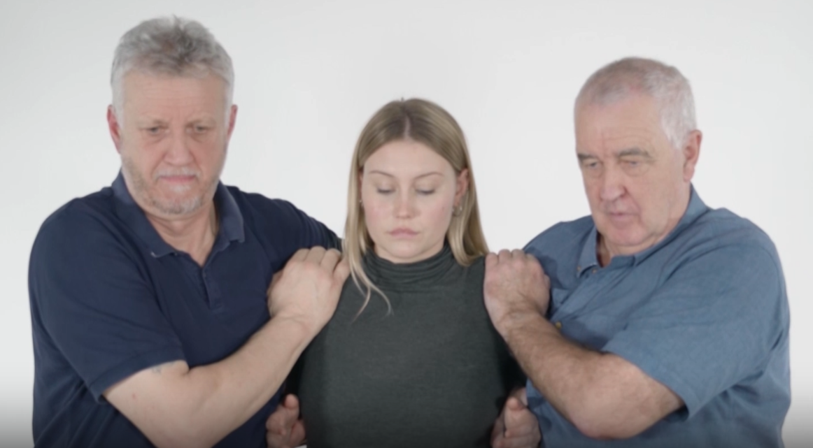 | Single Elbow standing alongside the person, holding the nearest forearm drawn back to be parallel to the ground with hands close to the chest and supporting pressure through the hip. The nearest hand holds the forearm with the other supporting the shoulder  Intervention number 1:  2-person single elbow guide, with ** on the left and ** on the right
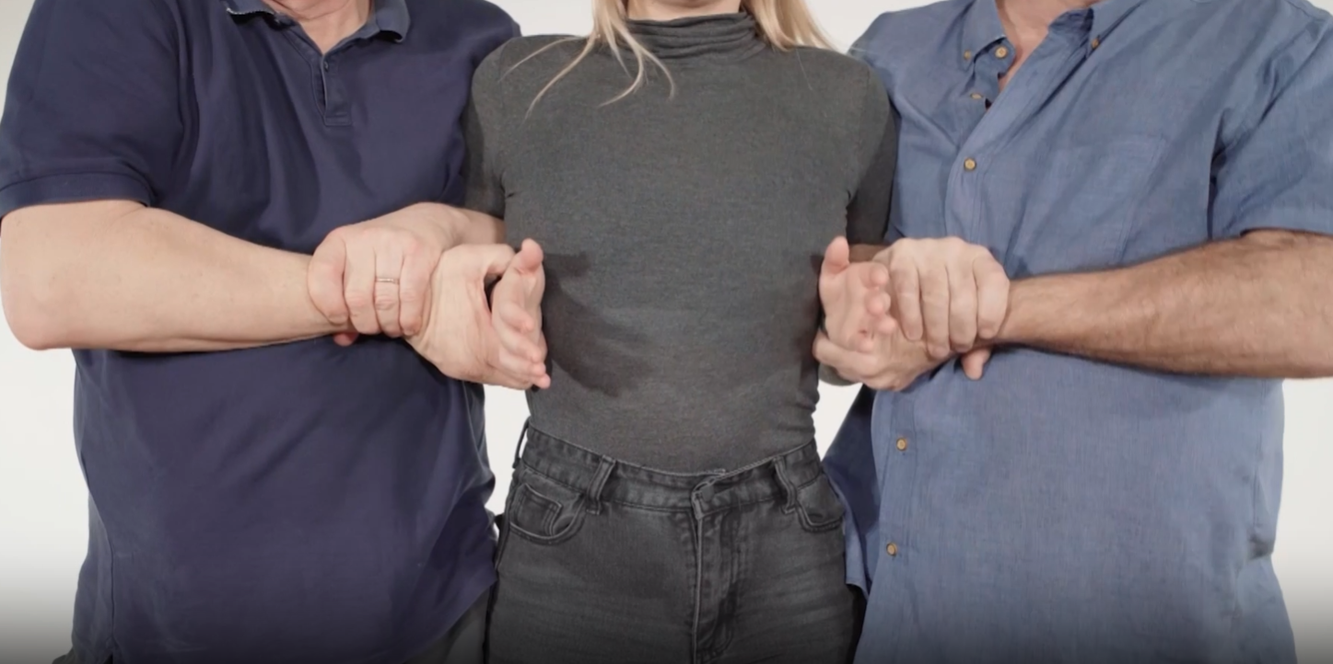 | Figure of Four standing alongside the person with the hand of the outer arm holding underneath the person’s nearest forearm and the other passing under the armpit, across the top of nearest forearm to hold own wrist.  Intervention number 2:  2 person figure of four in a ** position with ** on the left and ** on the right
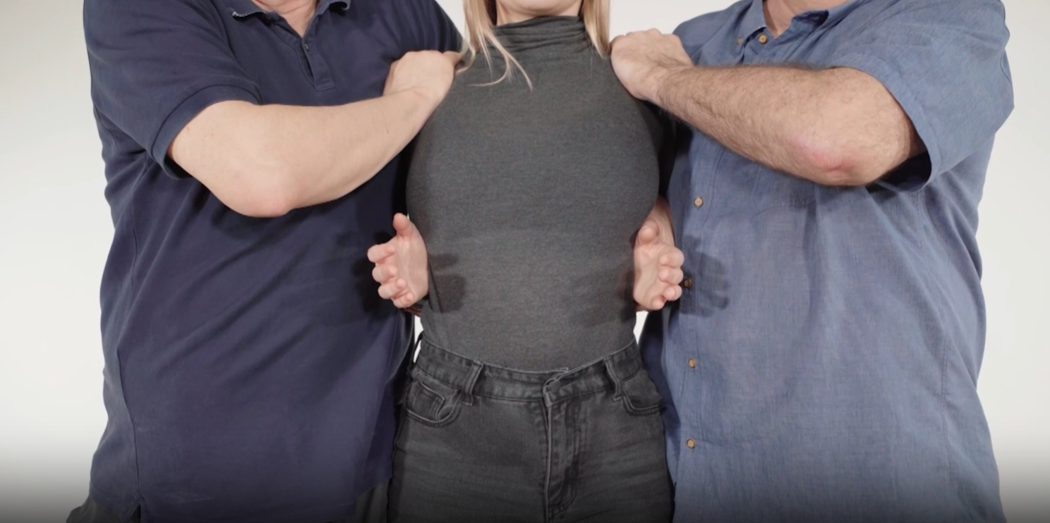 | Double Elbow Standing alongside the person, holding both forearms drawn back to be parallel with the ground with hands close to the chest and supporting pressure through the hip. One arm is supporting the person’s back.  Intervention number **:  2 person double elbow hold in a ** position, with ** on the left and ** on the right
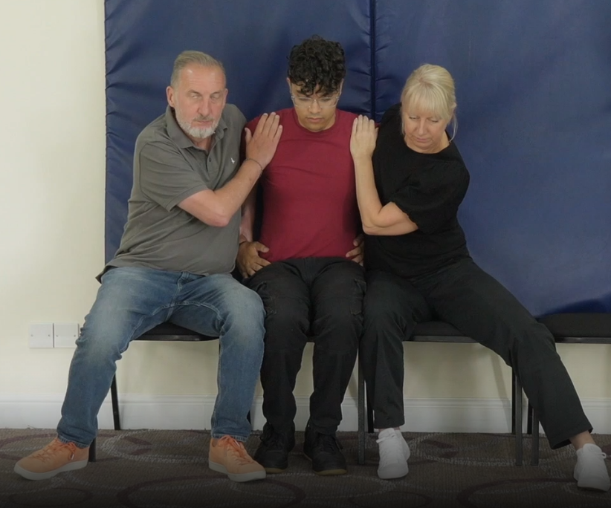 | Two person seated hold holding both forearms drawn back, hands in a seatbelt position on the hips, arms/elbows drawn out towards adults back.Seated in an upright position to ensure correct posture preventing elevated risks.  2 person seated hold, with ** on the left and ** on the right
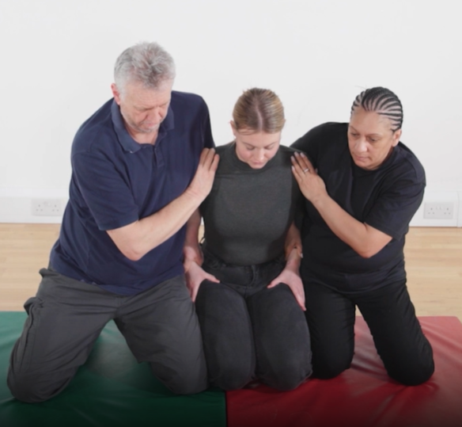 | Two person response to deadweight in kneeling position holding both forearms drawn back, hands in a seatbelt position on the hips, arms/elbows drawn out towards adults back.Seated in an upright position to ensure correct posture preventing elevated risks.  2 person response to deadweight hold in a kneeling position, with ** on the left and ** on the right
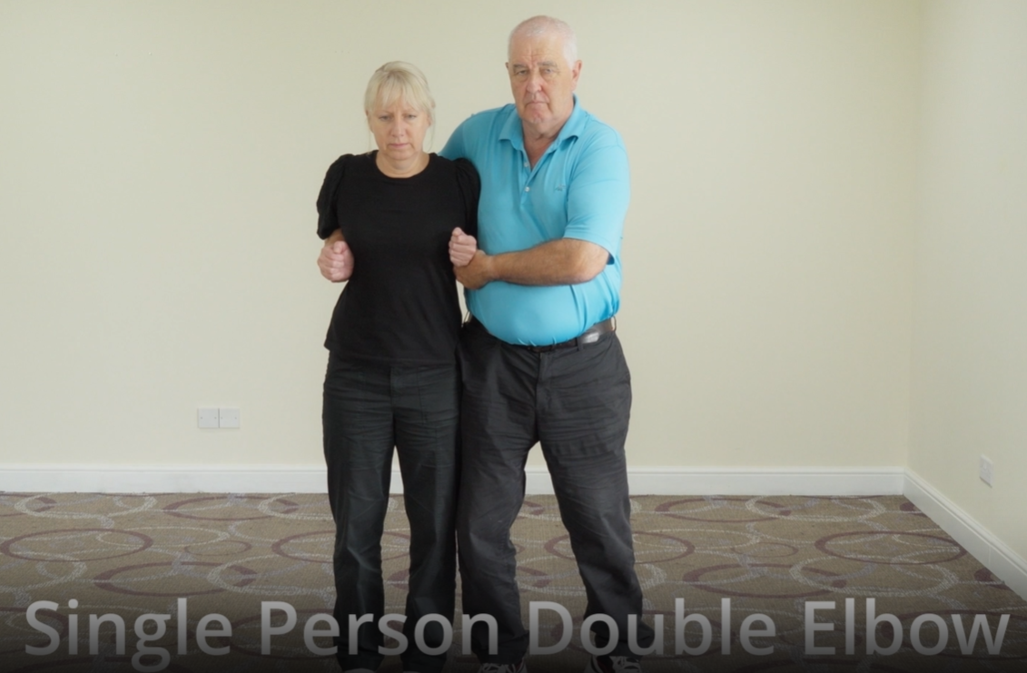 | Double Elbow Standing alongside the person, holding both forearms drawn back to be parallel with the ground with hands close to the chest and supporting pressure through the hip. One arm is supporting the person’s back.  Intervention number **:  1 person double elbow hold in a ** position, with ** supporting both arms.
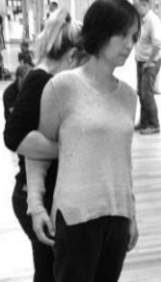 | Half Shield - contact in a T shape stance with their hip to the small of the person’s back. The arm nearest is posted in front of the arm of the client, to prevent it from punching forward, with the back of the member of staff’s hand flat along the person’s back. The members of staff gather the other arm with a Caring C, aiming to secure just above the elbow, maintaining contact at the hip. The member of staff should walk forward as the person crabs sideways.  Intervention number **:  Half shield with ** linking left/right arm
 | Help hug – low restriction physical intervention with one hand using a caring C just above one elbow, with the other hand bandaging the other elbow and drawing it into the pupils side.  Intervention number **:  Seated Help Hug with ** supporting left and right arm.
 | Leg support ** provided leg support by wrapping their arms around the legs from a position seated below the child.

Changes, releases, re-engages include information why changes, releases and re-engages happened

Description of de-escalation, calming process and release

Name of person who used the measure |  | Name of person who used the measure
Name of person who used the measure |  | Name of person who used the measure
Other person present |  | Other person present
Other person present |  | Other person present

Was the measure effective?

Consequences for any behaviour prior to physical intervention (if applicable)
Behaviour points not earnt | Loss of Trip | Home communication
Full Reward Time not earned | Computer Ban | Police Contacted
Complete unfinished task | Repair damage / clear mess | Other

Description of any injury to the child
Did the intervention result in injury to the child? |  | Yes/No
Was this self-injurious? |  | Yes/No
If injury occurred, has this been recorded in the accident book? |  |  | Accident Number
Detail of any injuries, (please mark on the body map) | Body Map
 | 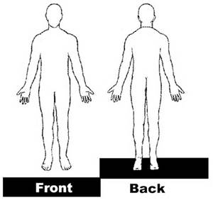
Description of any medical treatment administered

Safe and well check – Post incident
During / Immediately post incident | 1 hour post incident | Follow up

Description of any injury to any other person
Did the intervention result in injury to another person? |  | Yes/No
Was this self-injurious? |  | Yes/No
If injury occurred, has this been recorded in the accident book? |  |  | Accident Number
Detail of any injuries, (please mark on the body map) | Body Map
Description of any medical treatment administered

Discussion and Reflections – Child
What happened?

Why were you held?

Could you have dealt with the issue in a different way?

How can we help each other move forward?

Have you sustained any injuries?

Staff Signature | Staff name | Child Signature

Discussion and Reflections – Staff
How could you have acted differently?
Was the intervention in line with the child’s behaviour plan and risk assessment?
Have you discussed and reflected upon the safe-hold with your colleagues?
Have you sustained any injuries?
Are amendments to risk assessments or behaviour plans necessary?
Risk Assessment | Behaviour Plan

Record of any damage all damage should be reported to the headteacher and admin.

Further Information incl. date, time and name of individuals to whom information has been reported incl. copies sent
Please put a ‘X’ where appropriate | N/A | Date | Time | Names | Nature of communication | Who communicated
Member(s) of SLT
Parents or Guardians
Social Worker
Placing Local Authority
Ofsted Notification
Safeguarding Referral

Signatures – after being discussed with, and agreed by, all parties involved
Staff directly involved | Signature | Date
Staff directly involved | Signature | Date
Staff directly involved | Signature | Date
Staff directly involved | Signature | Date
Other person present | Signature | Date
Other person present | Signature | Date

Summary of SLT Reflections
Senior Leader | Signature | Date | Please confirm details of any injury to a child or other person

